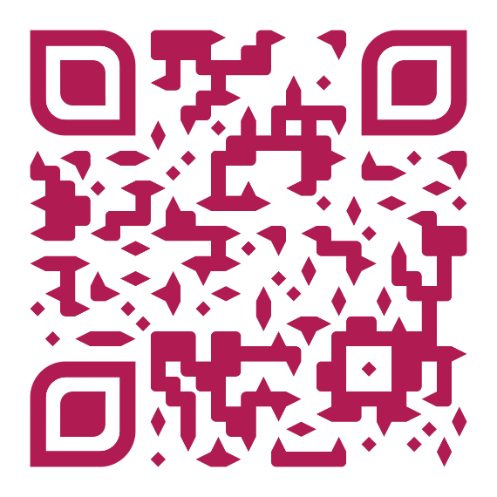

<https://www.qrcode-monkey.com/>

#B01C52